Sample Poster
RBR013

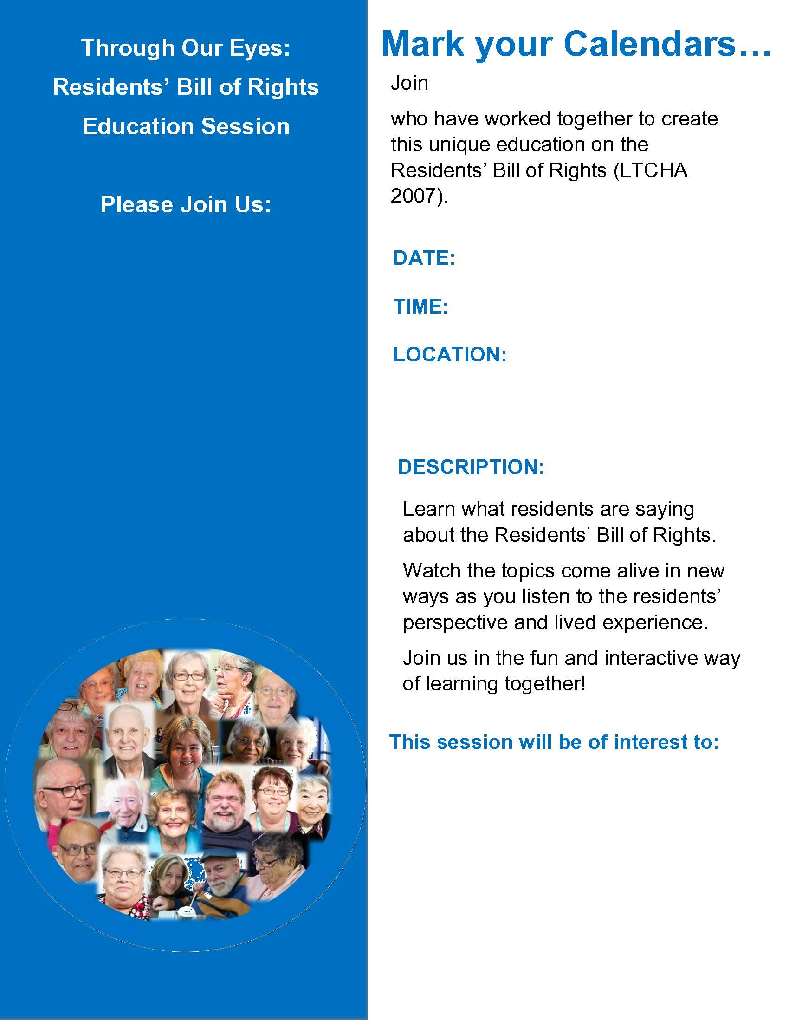
Add a picture of
the presenters

Add the
Presenters Names

