# Sample Poster

RBR013

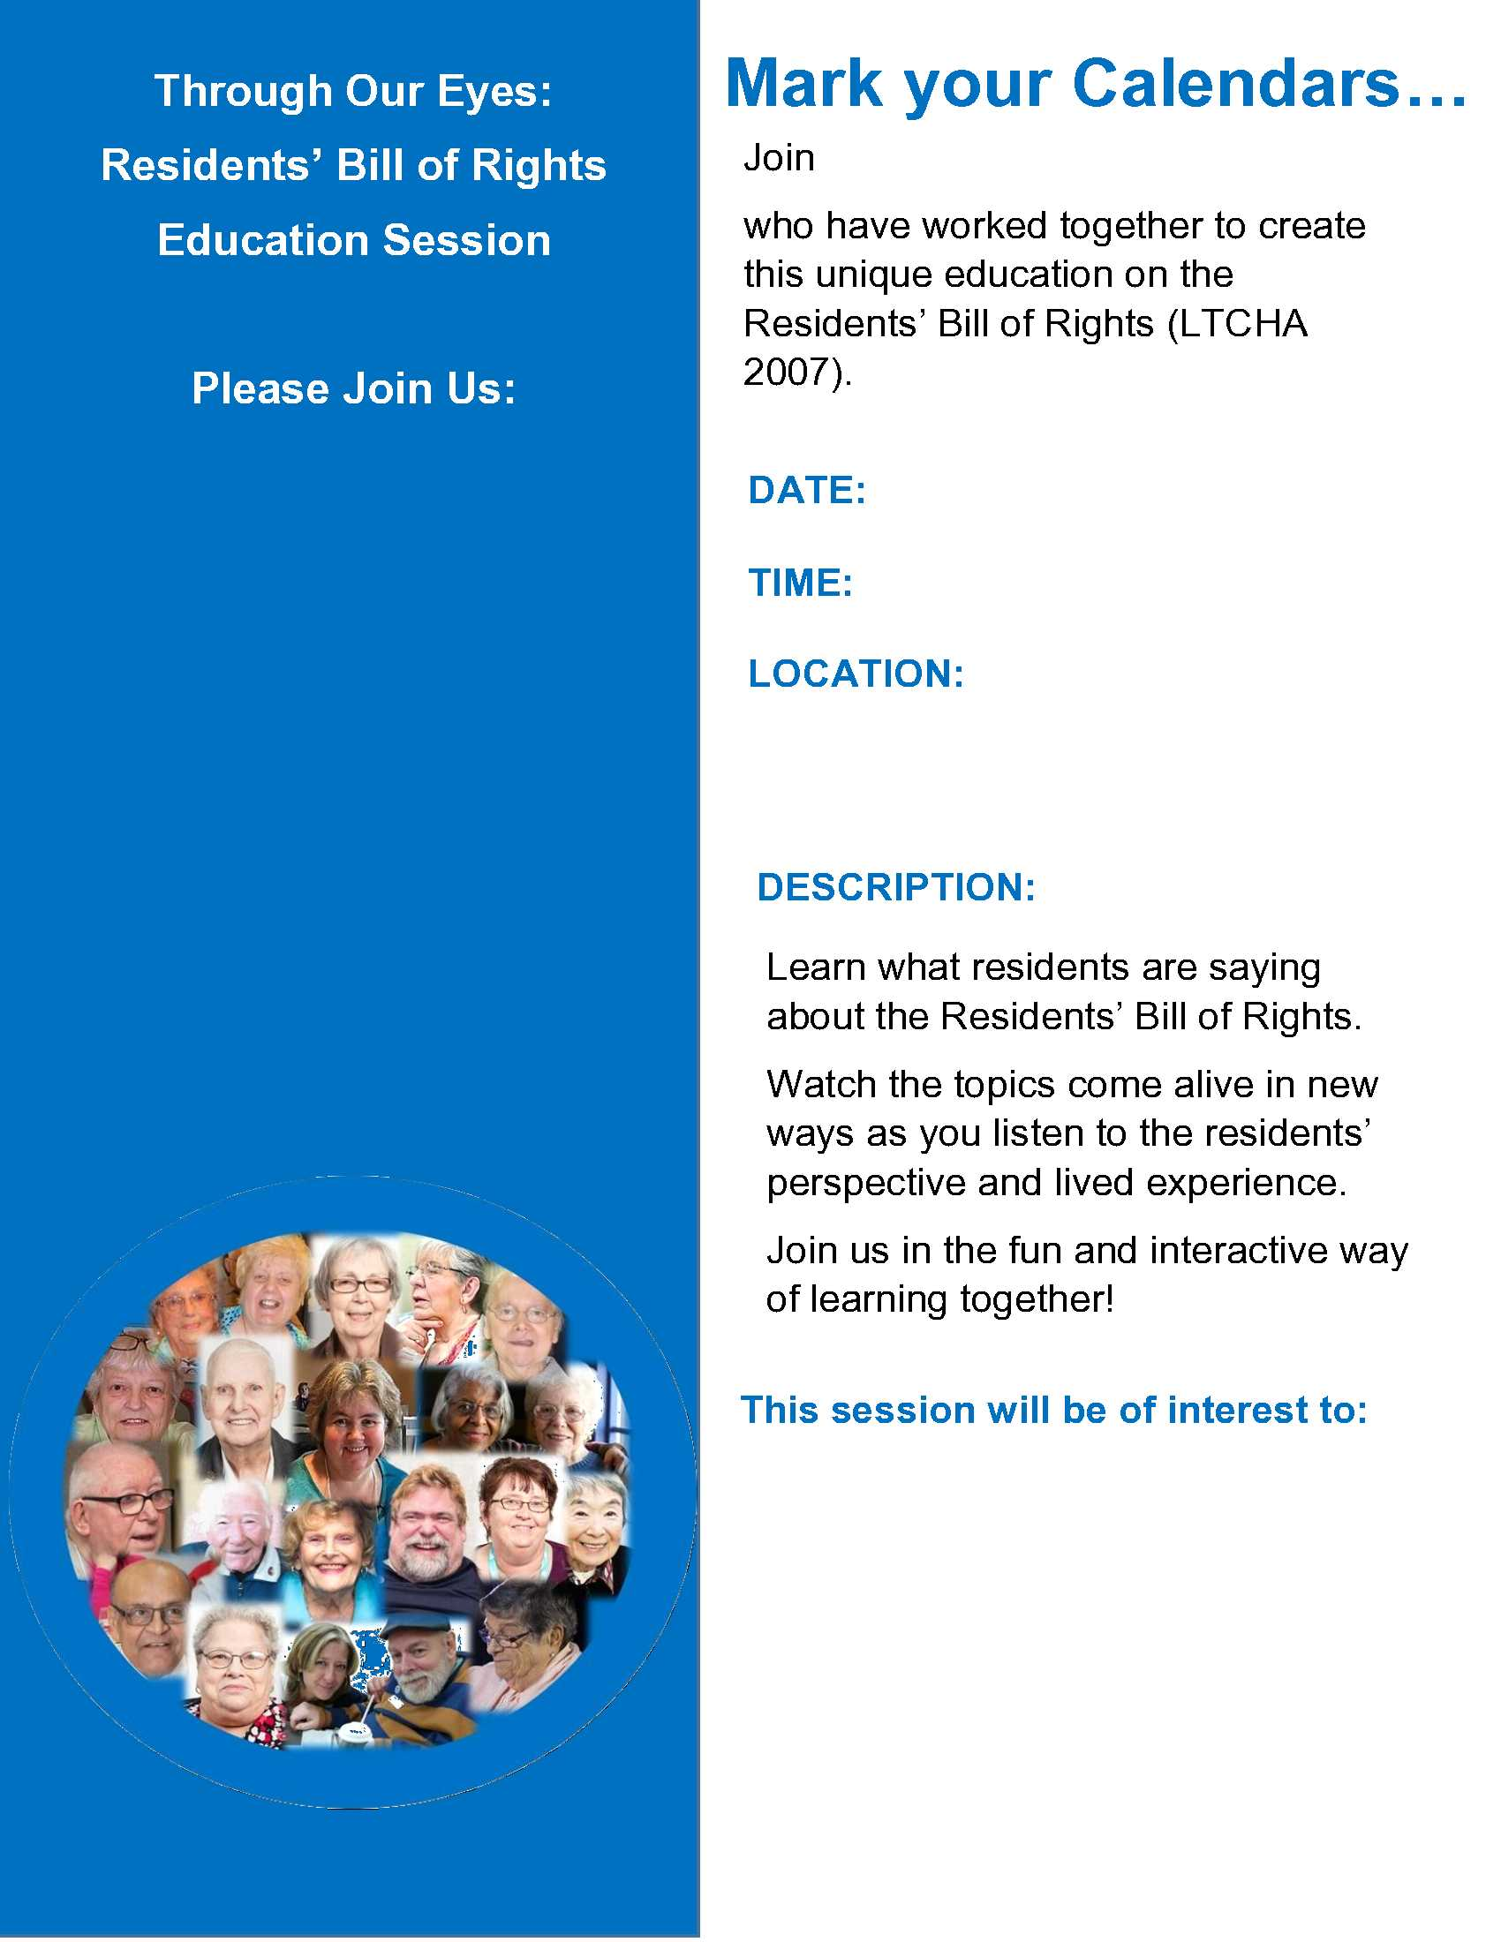

Add a picture of

the presenters

Add the

Presenters Names